**Project Report**

**Implementation and Evaluation of Graph Theory Algorithms**

**Design and Analysis of Algorithms**

**Submitted By**

**Talha jamal k17-3877**

**Satish kumar k17-3756**

**Abstract :**

**Firstly we worked on the inputs and try to generate graph from those inputs , then we get the code of dijkstra , prims…. From geeksforgeeks and then modify it according to the given requirement.**

**Introduction :**

**Summary of the problem is that there are multiple inputs are given from which user choose the particular input and their required graph from prims , kruskal , dijkstra , bellman ford , clustering and coefficient visually display on the console .**

**Experimental Setup:**

The given Experimental Setup Require To Copy all the Benchmark Files as Input into same folder as Project Code cpp file and then run the code select the input file and then select the graph you Want to plot and thus your graph is plotted.

**Diagram :**

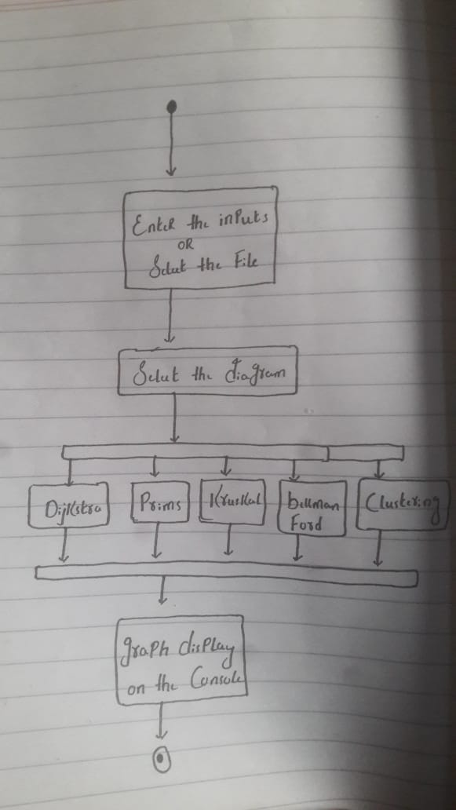

**Inputs :**

**All the inputs (input10….input100) are in the benchmark folder .**

**Output :**

|  |  |  |  |  |  |
| --- | --- | --- | --- | --- | --- |
| **Benchmarks** | **Prims** | **Kruskal** | **Dijkstra**  **Algorithm** | **Bellman**  **Ford**  **Algorithm** | **Clustering coefficient (local clustering)** |
| **Input 10** | **30** | **30** | **82** | **82** | **0.74** |
| **Input 20** | **71** | **71** | **180** | **180** | **0.96** |
| **Input 30** | **96** | **96** | **241** | **241** | **0.94** |
| **Input 40** | **157** | **157** | **430** | **430** | **0.85** |
| **Input 50** | **159** | **159** | **515** | **515** | **0.87** |
| **Input 60** | **218** | **218** | **1133** | **1133** | **0.89** |
| **Input 70** | **245** | **245** | **952** | **952** | **0.83** |
| **Input 80** | **298** | **298** | **851** | **851** | **0.95** |
| **Input 90** | **337** | **337** | **1296** | **1296** | **0.89** |
| **Input 100** | **353** | **353** | **1238** | **1238** | **0.91** |

**Floyd Warshall Output :**

**Input10:**



**Input20:**



**Input30:**



**Input40:**



**Input50:**



**Input60:**



**Input70:**



**Input80:**



**Input90:**



**Input100:**



**Conclusion:**

**Graph theory is an exceptionally rich area for programmers and designers. Graphs can be used to solve some very complex problems, such as least cost routing, mapping, program analysis, and in Our Course of Data Analysis And Algorithm We have Implemeted Prims, Kruskal, BellmanFord, Clustering coefficient (local), Dijstra, Floyd Warshall in the project with Visual Representation.**

**References :**

**Bellmen ford :** <http://www.cplusplus.com/forum/beginner/241629/>

**Prim’s :** <https://www.geeksforgeeks.org/prims-minimum-spanning-tree-mst-greedy-algo-5/>

**Dijkstra’s :** <https://www.includehelp.com/cpp-tutorial/dijkstras-algorithm.aspx>

**Kruskal’s :** <https://www.geeksforgeeks.org/kruskals-minimum-spanning-tree-using-stl-in-c/>

**Floyd warshall :** <https://www.sanfoundry.com/cpp-program-implement-floyd-warshall-algorithm/>

**Clustering Coefficient Local:** <http://qasimpasta.info/data/uploads/sina-2015/calculating-clustering-coefficient.pdf>